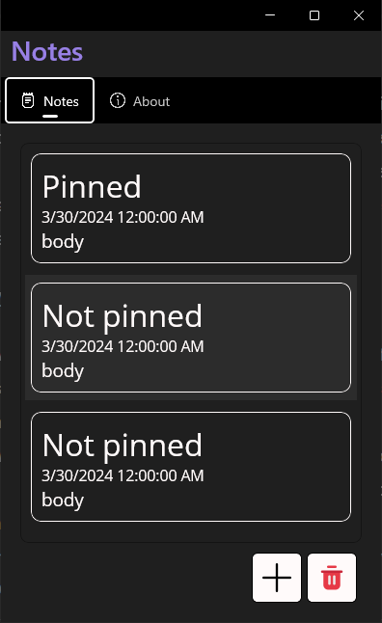 Keep Notes

# Background/Motivation:

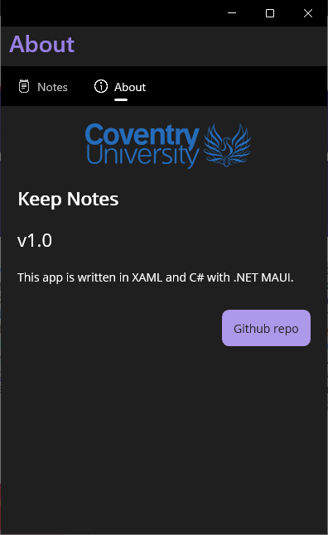The "Keep Notes" application has been developed to offer users a user-friendly interface for recording and organizing various types of information such as ideas, reminders, and musings that they desire to retain for future reference. Considering the growing dependence on digital solutions for task organization and information management, a straightforward yet efficient notes application becomes indispensable. The "Keep Notes" application was designed with the intention of providing users with a visually appealing and user-friendly interface for effortlessly creating, managing, and organizing their notes.

# Summary of Features:

List View of Notes: All the recorded notes are displayed in a list view on the application's homepage. Subject, substance, and date of origination comprise each note entry.

The "plus" icon, when pressed, initiates the addition of a new note, whereupon a screen prompts the user to enter the note's subject, content, and whether it should be pinned to the top and the date regarding the note.

Save and Discard: Users are presented with the choice to preserve their input by selecting the "Save" icon when adding a new note. Conversely, they have the option to delete the modifications by selecting the "Discard" icon.

attach to Top: While adding or editing a note, users have the option to attach specific notes to the top of the list by toggling the "Pin to Top" checkbox. Users are able to prioritize notes that are critical or frequently accessed using this function.

By selecting a note entry from the primary list view and tapping it, users are directed to a detailed view of the note. In this view, they are able to modify the subject, content, and creation date of the note.

Delete Notes: By hitting on the "trash" button, which opens the selection mode, users can choose and remove several notes at once. Users are presented with checkboxes adjacent to each note in this mode, enabling them to select which ones they wish to delete.

The "About" page of the application provides details regarding the application, including its name, version, and a hyperlink to the GitHub repository through which the source code can be accessed.

Visual Enhancements: To improve the overall user experience, the user interface incorporates aesthetically pleasing components such as rounded frames, transparent backgrounds, and graphical controls.

In general, the "Keep Notes" application offers users a streamlined yet all-encompassing solution for effectively managing their notes. Users may utilize this application to maintain the accessibility and organization of their information, whether it be for organizing comprehensive thoughts or jotting down quick reminders.

The "Keep Notes" application also flaunts powerful data set mix, consolidating nearby capacity to work with fundamental CRUD (Create, Read, Update, Delete) tasks, also includes a modestly mind-boggling UI with various pages, including the primary notes page, add note page, show page, and about page. Each page contains different UI components, for example, text section fields, checkboxes, fastens, and marks, giving clients exhaustive usefulness. The utilization of information restricting and MVVM engineering improves the association and the significant board information, guaranteeing consistent correspondence between the UI and hidden information model. Moreover, the joining of highlights like choice mode and route between pages adds profundity to the client experience, considering productive notetaking and association. Despite its intricacy, the application keeps up with lucidity and convenience, making it available to clients across various stages and gadgets.